Foothil college
Quality Soft Contact List
Software Design Document
CIS001A Team 6 (Eleana, Anaga and Satyen)
3/8/2013

Design document for Quality Soft contact list application developed by CIS001A Java Team 6

Contents
1. INTRODUCTION 2
1.1. Purpose 2
1.2. Scope 2
1.3. Overview 2
2. SYSTEM OVERVIEW 2
3. SYSTEM ARCHITECTURE & STANDARD CLASSES 2
4. DATA DESIGN 4
5. USER INTERFACE DESIGN 4
6. APPENDICES 4
7. Revision History 5

INTRODUCTION

Purpose
This software design document describes the architecture and system design of QSCL (QualitySoft Contact List) application. This application will be deployed at a local nonprofit organization.

Scope
This document describes the implementation details of the QSCL application. This application will consist of a two major functions. First to design the Contact List class that will store, restore and operate on contacts, and a Test application that will ensure all the functions in the Contact List class are working as per the design. In the initial release this application will support the use case 1 to 5. If time permits the application will be extended to support the optional use case 1A.

Overview
Quality Soft Contact List application meets the requirements as outlined in the uses cases provided QualitySoft systems analyst.
- Case 1 : Enter a new person
- Case 2 : Print the contact list
- Case 3 : Retrieve a person's information by last name
- Case 4 : Retrieve a person's information by email address
- Case 5 : Retrieve all people who live in a given zip code
- Case 1A (Optional): Enter a new person

For more details on the use cases, refer to Appendix 1 (UseCases.pdf)

SYSTEM OVERVIEW
The QSCL application will be developed using the Java language. It will use various development concepts to make it scalable and easy to maintain. The following are some of the development techniques it will use:
- Oriented orient programming to encapsulate data and provide access through public interface methods.
- Multi-tier architecture to separate UI from business objects
- Modular design: To provide easy maintenance
- Load on request: For speed and scalability

SYSTEM ARCHITECTURE & STANDARD CLASSES

QSCL application will use the following classes, which must be developed:
- User interface classes: This will be a simple console application. The UI will interact with the Contact List class to perform the operation/fetch the result. This UI can be easily replaced with Win forms or Web forms at a later date, based on user necessity.
- Contact List Class: This class will hold all the contacts and perform all the actions that the UI requests. The class will use the Contact class to delegate some of its tasks.
- Contact Class: An instance of this class will represent the details of a contact.

The following diagram demonstrates how these classes interact with each other.
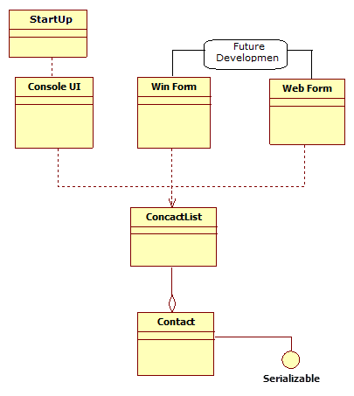

Besides developing the above classes, here are list of standard Java classes that this application may/will use:

- java.io
- java.util.*;
- java.io.Serializable
- java.io.EOFException;
- java.io.FileInputStream;
- java.io.FileOutputStream;
- java.io.IOException;
- java.io.ObjectInputStream;
- java.io.ObjectOutputStream;
- java.util.Iterator;
- java.util.List;
- java.util.ArrayList;

During development if we may also include other standard java classes as required by the application.

Development will be coordinated through Git (via GitHub) for version control, and Google Documents for documentation purposes.

DATA DESIGN
QSCL will store the contact list using Java serialized objects to the hard disk in the Contacts.dat file.

USER INTERFACE DESIGN
Currently the QSCL application uses a simple console class as its UI. However, since the application is modularized, the UI component can be easily replaced with a Windows GUI interface or Web interface.

This version of the UI (1.2) has a menu of 5 options, the use cases. Please see Appendix 6 (ContactListUI.java).

In its next implementation, the UI will have a Main Menu of 3 options (Add contact, Print contact list, and Search for a contact) that is displayed to the user as a numbered list. The user enters the number that corresponds to the action they want and it is executed.

The UI will combine use cases 3, 4, and 5 into one option in the Main Menu entitled simply “Search for a contact.” Upon selecting that option, the user will be asked to choose if they would like to search by last name, email address, or zip code (use case 3, 4, or 5).

After the chosen action is executed, the Main Menu appears again.

See Appendix 7 (FakeRunRecording.txt) for a sample run using the future UI.

APPENDICES

1 | UseCases.pdf | Details of all the uses cases referred in overview section
2 | Contact.java | The skeleton for class Contact, to be fleshed out upon acceptance of design
3 | ContactList.java | The skeleton for class ContactList, to be fleshed out upon acceptance of design
4 | TestContact.java | A program that tests every method of class Contact.
5 | TestContactList.java | A program that test every method of class ContactList.
6 | ContactListUI.java | A sample console-based UI for the contact list.
7 | FakeRunRecording.txt | A fake recording of a sample run of the program, implementing all five use cases.

Revision History

Date | Version | Status : Creation / WIP / App. | Author
Mar 06, 2013 | 1.0 | Creation | Satyen
Mar 07, 2013 | 1.1 | Review | Anaga
Mar 08, 2013 | 1.2 | Creation & Final Review | Elena

